In conclusion, we attempt to answer the question of which decade of NBA players from the 80s to the 2000s.

With this data here are our findings to the following three hypothesis:

1. If overall index of average players in the 2000s and 90s is greater than 80s, then average players have become more skilled since the 80s.

From the stats and visuals we see that average player overall indices from 2000s and 1990s were lower than average players from the 1980s. Thus we reject our hypothesis and accept the alternative of average players actually having decreased in overall indices since the 80s .

So why is this the case? Here are our theories:

The average NBA player’ offensive index has actually gotten worse . Average PPG by position has gone down decade by decade as has the overall index. When considering the defensive index, only one position (SG) has seen the average defensive index go up. We have several theories as to why

A-expansion: The NBA has added seven teams since 1980. The number of players has increased which is dragging down the mean.[1]

B-increase reliance on outside shots

C-game appears to be less reliant on big men or center, if shooting guards have an increase in their defensive index (they do), we can theorize that’s because more shooting guards are initiating the offense. Shooting guards typically guard shooting guards. This would be another interesting stat to look at for future studies with how the role has changed offensively over the years.

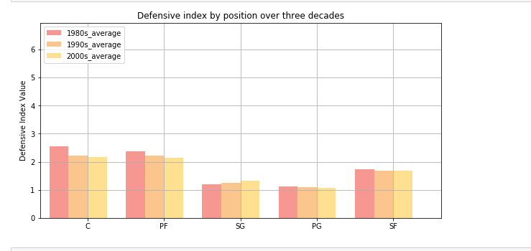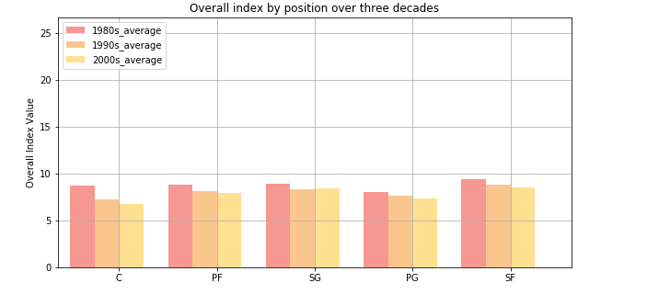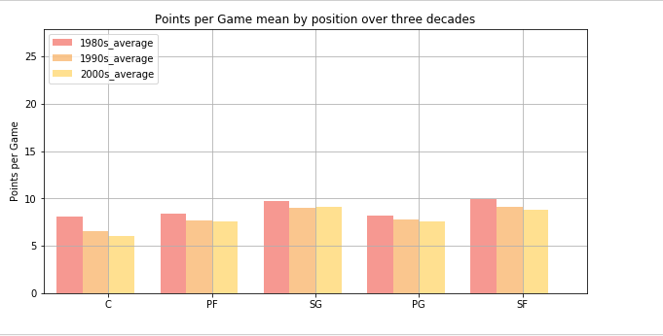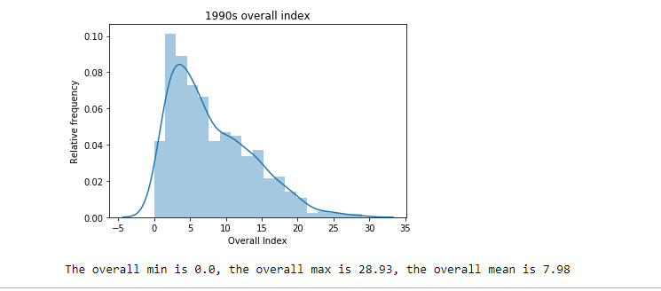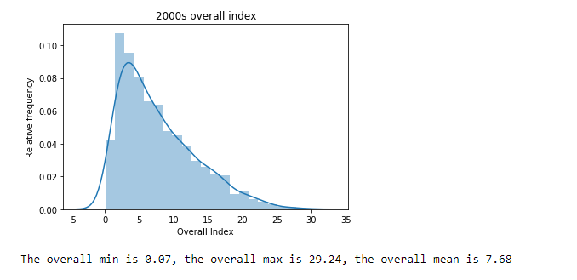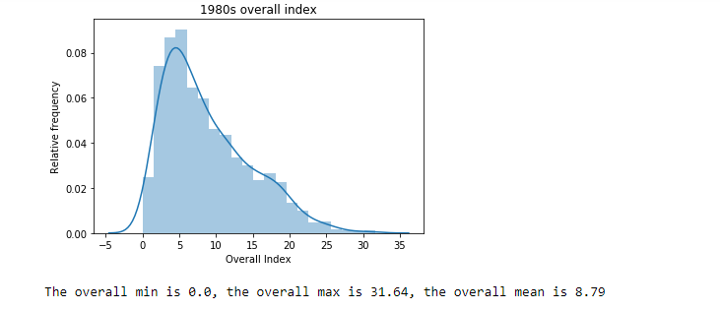

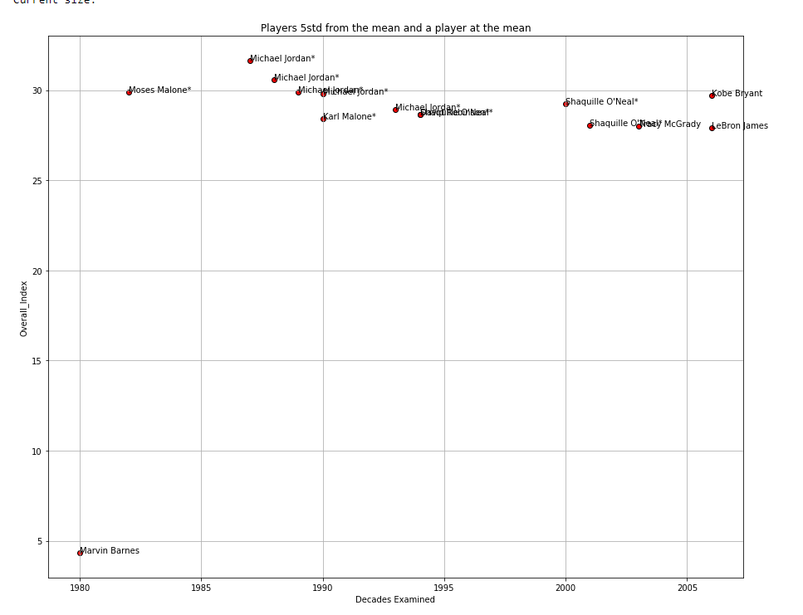

1. If offensive index is greater than 2standard deviations, then the player is defined as having an elite offensive season.

From the stats and visuals, we are able to accept the hypothesis. However, data shows most of the players that the general populace regard as the best of the era are not just 2 deviations from the mean but two or more times that.

For the normal distribution, the values less than one standard deviation away from the mean account for 68.27% of the set; while two standard deviations from the mean account for 95.45%; and three standard deviations account for 99.73%. Our distribution is not normal because there are multiple players that sway the chart heavily to the lower end of the chart.

Using our algorithm to determine defensive values, even an average defensive player is considered an elite. It greatly over exaggerates average defensive skills.

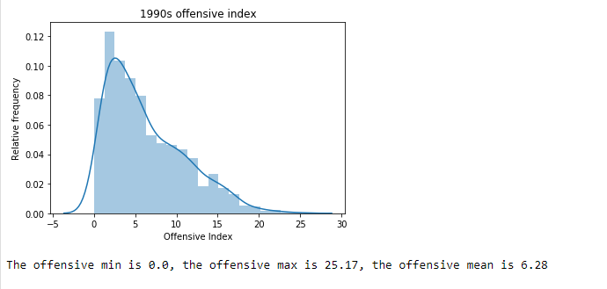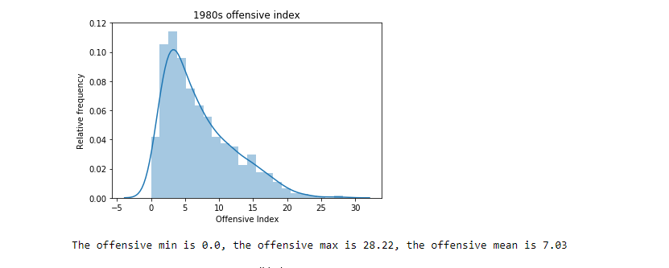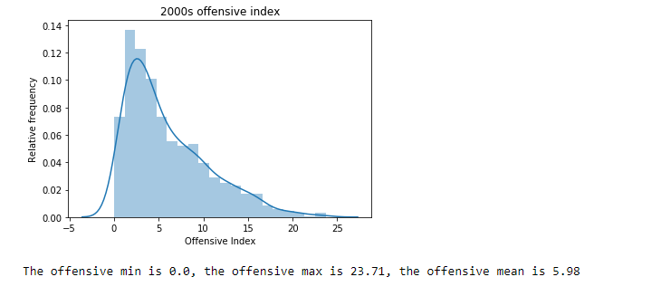

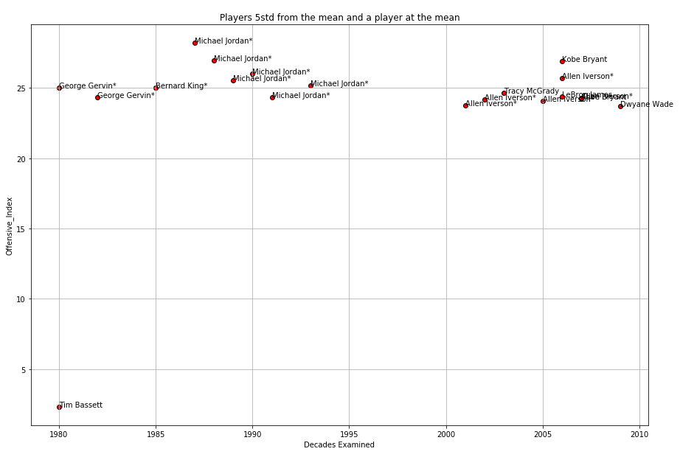

1. If defensive index is great than 2 standard deviations, then the player is defined as having an elite defensive season.

From the stats and visuals, we are able to accept the hypothesis. However, data shows there are 63 individual player seasons where a players defensive index was greater than 5 STD from the mean. When you compare defensive to the offensive distributions, offensive distributions only had 19 individual player seasons.

So why such a high defensive value total? The Standard deviation is 1.2 from 1980-2010. Taking players 2 standard deviations from the mean and labeling them as elites is not saying much when the mean of our samples of each decade hovers around 1.7.

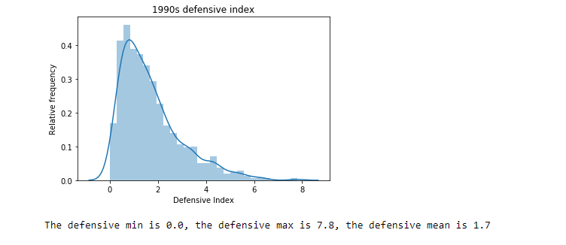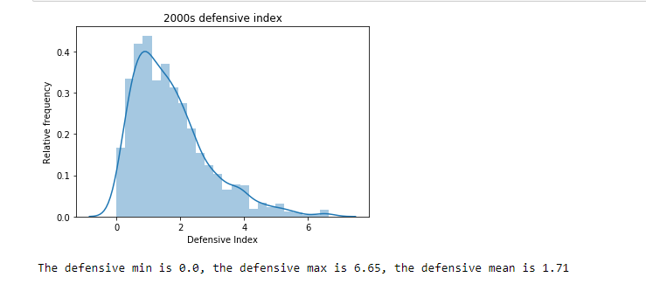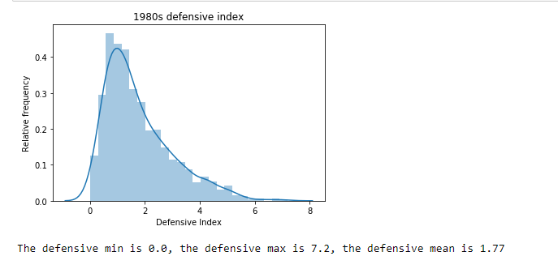

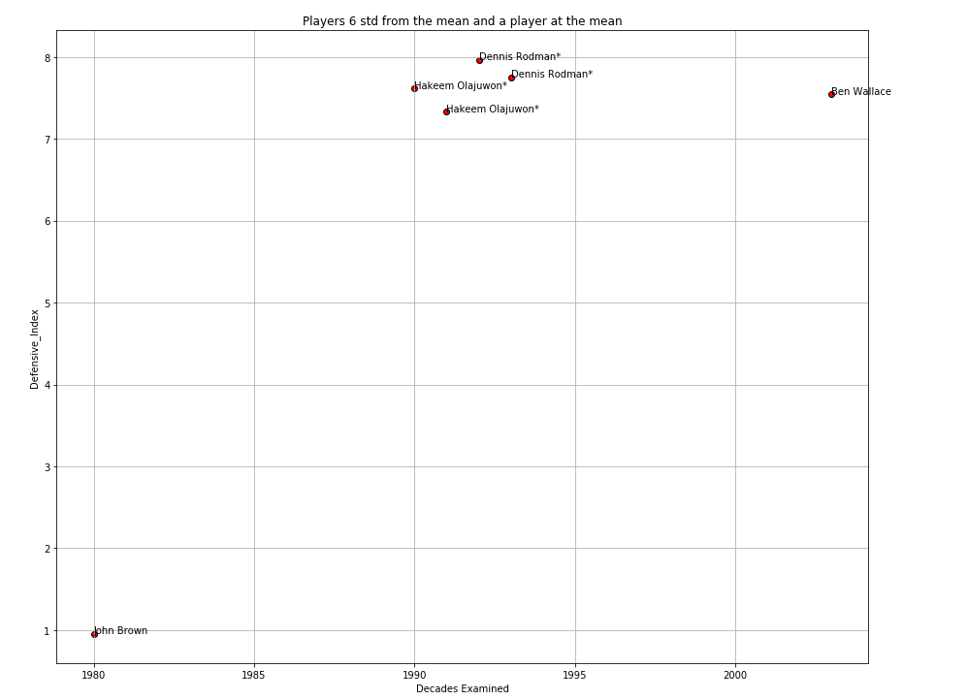

1. <https://en.wikipedia.org/wiki/Expansion_of_the_National_Basketball_Association#Modern_expansion:_1980%E2%80%93present>